[Eyebrow] **Software & Services**

[Headline] **End-to-End Lifecycle Monetization and Billing**

[Sub] **For growing your cloud business**

Digital River is a full-service ecommerce partner driven to grow your cloud business in a smart, sustainable way. Since 1994, we’ve helped many of the biggest brands in software and services navigate ecommerce complexities, empowering both direct-to-consumer and partner channel sales. We’re the only cloud-based vendor with an end-to-end ecommerce solution capable of supporting subscriptions, Commerce of Things, [channel partner management](https://www.digitalriver.com/solutions/commerce/smartchannel/), and both [digital and physical fulfillment](https://www.digitalriver.com/solutions/commerce/physical-and-digital-fulfillment-value-brief/).

**Platform & Scale**

Multi-tenant cloud infrastructure with 99.997% uptime handles the highest traffic bursts with ease. Our platform provides scalability and reliability to power your business with agility and speed to revenue.

**Payments & Billing**

Unparalleled global payments and localization capabilities help you achieve optimal authorization rates and increase sales. Our flexible billing options are built to strengthen your recurring revenue model.

**Customer Experience**

Advanced order management, commerce and communication tools enable you to deliver a superior end user experience while extending your ecommerce subscription sales to your channel partners.

[Header] **Powering World-Class Brands**

[insert client logos and text below]

[Code42 logo]

Powering subscriptions and global expansion for Code42’s CrashPlan solution.

[Avast logo]

Powering Avast’s antivirus subscriptions and shopper experience.

[Adobe logo]

Powering Adobe’s Creative Cloud subscriptions in more than 50 countries worldwide.

[Kaspersky logo]

Powering subscriptions for Kaspersky’s award-winning security products.

[Intel logo]

Powering McAfee’s SMB subscriptions and channel partner sales.

[Autodesk logo]

Powering localized subscription sales for Autodesk in APAC and EMEA.

[Header] **Lifecycle Monetization & Billing**

[Sub header] **Acquire and Delight Customers**

Combine our global ecommerce expertise and agile platform with one of two world-class marketing solutions for superior end-to-end experience management. Whether you choose our award-winning [in-house marketing services](https://vimeo.com/159538403) or our integration with [Adobe Experience Manager](https://www.digitalriver.com/marketing_material/digital-river-adobe-experience-manager/), Digital River helps you keep customers delighted throughout the lifecycle.

[Sub header] **Optimize Customer Conversions**

Our extensive global payments and localization capabilities allow you to achieve optimal conversion rates. Our central payment gateway enables 41 payment methods, 108 display currencies and 46 transaction currencies. This localization of language, currencies and cultural nuance provides a tailored individual customer experience.

[Button] [LEARN MORE](https://www.digitalriver.com/marketing_material/global-commerce-payment-capabilities-infographic/)

[Sub header] **Reduce Churn and Maximize Your Subscription Profitability**

To increase retention, we offer an innovative toolset to drive down both voluntary and involuntary churn. With over 10 years of subscription billing experience, we are the industry’s foremost experts on reducing involuntary churn. We help many of the biggest subscription brands increase revenue by as much as 12%!

[Button] [LEARN MORE](https://www.digitalriver.com/solutions/commerce/subscription-revenue-optimization-value-brief/)

[stat callout and visualization graphic to incorporate in the “retention” section] Increasing customer retention rates by 5% increases profits 25-95%!

[link and banner to churn calculator]

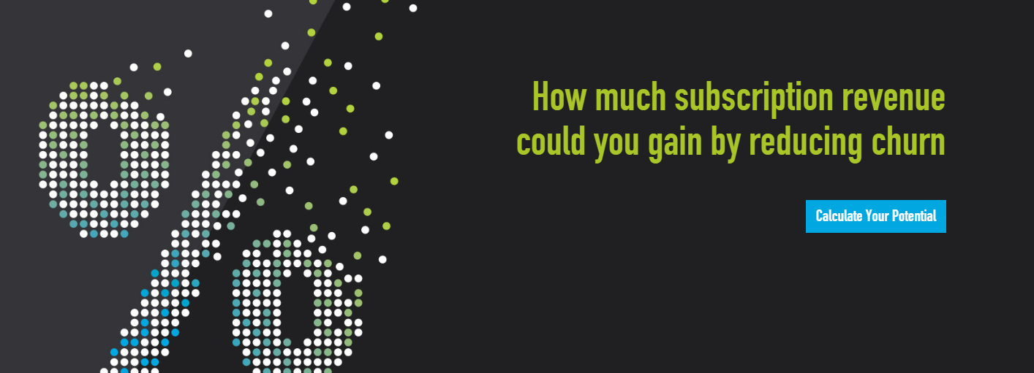

[Header] **See what the experts are saying**

“Digital River will be a strong fit for software firms looking to monetize cloud versions of their enterprise and consumer software suites across global markets.”

The Forrester Wave™: Subscription Billing Platforms, Q4 2015 (November 11, 2015)

[Forrester logo]

“A SaaS platform primarily to B2C businesses in industries such as software, gaming and media.”

Critical Capabilities for Digital Commerce (April 28, 2015)

[Gartner logo]

[Headline] **Why Work With Digital River**

**FULL SERVICE**

We’re the only subscription provider that offers end-to-end ecommerce including [experience management](https://www.digitalriver.com/solutions/commerce/commerce-experience/), marketing, global localization, entitlements and digital rights management, [merchant of record](https://www.digitalriver.com/solutions/commerce/commerce-business-infrastructure-merchant-and-seller-of-record-value-brief/), core commerce services, subscription management, [order management](https://www.digitalriver.com/solutions/commerce/order-management/) and payments.

[visualization graphic for 96% stat callout] 96% of decision makers agree that consolidating capabilities in a single solution would improve their ability to reduce involuntary churn.

Source: A commissioned study conducted by Forrester Consulting on behalf Digital River, February 2017

**MOTIVATION**

Our percent-of-sale revenue model and economies of scale uniquely motivate us to maximize your revenue.

**SCALE**

We can allocate resources for ongoing analysis and discovery of new ways to drive down involuntary churn.

**GLOBAL LOCALIZATION**

Our [global payments](https://www.digitalriver.com/marketing_material/global-commerce-payment-capabilities-infographic/) and localization capabilities achieve the highest authorization for converting subscription renewals.

**EXPERIENCE & INNOVATION**

We’ve spent over 10 years on subscription technologies and were the first to identify Intelligent Transaction Routing.

**RISK MITIGATION**

We manage the [complexities and risk](https://www.digitalriver.com/solutions/commerce/commerce-business-infrastructure/) of complying with ever-changing tax and data privacy laws, and managing fraud with each new market you enter.